Leonardo Merza

ELCT 222

Homework #4

QUESTION 1 PART a

Vi=20e-3;%Volts

L=1e-3;%Henry

C=.01e-6;%Farads

R=33;%Ohms

Rl=2;%Ohms

ws=1/(sqrt(L\*C));

w=[0:10:2\*ws]; %frequency (Rad/s)

ZC=1./(1i.\*w.\*C);

ZL=1i.\*w.\*L;

ZR=R+Rl;

ZT=ZR+ZL+ZC;

I=Vi./ZT;

Vo=I\*R;

plot(w, abs(Vo));

hold on

R=100;%Ohms

ZR=R+Rl;

ZT=ZR+ZL+ZC;

I=Vi./ZT;

Vo=I\*R;

plot(w, abs(Vo));

hold on

R=1000;%Ohms

ZR=R+Rl;

ZT=ZR+ZL+ZC;

I=Vi./ZT;

Vo=I\*R;

plot(w, abs(Vo));

hold on

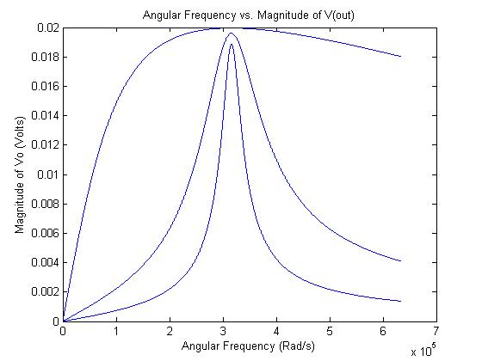

QUESTION 1 PART b

Vi=20e-3;%Volts

L=1e-3;%Henry

C=.01e-6;%Farads

R=33;%Ohms

Rl=2;%Ohms

fs=1/(2\*pi\*sqrt(L\*C));

w=fs\*2\*pi;

XL=w\*L;

ZR=R+Rl;

Qs33=XL/ZR %Q factor

BW33=fs/Qs %Bandwidth

R=100;

ZR=R+Rl;

Qs100=XL/ZR %Q factor

BW100=fs/Qs %Bandwidth

R=1000;

ZR=R+Rl;

Qs1000=XL/ZR %Q factor

BW1000=fs/Qs %Bandwidth

Qs(33) = 9.0351

BW(33) = 1.5947e+005 Hz

Qs(100) = 3.100

BW(100) = 1.5947e+005 Hz

Qs(1000) = 0.3156

BW(1000) = 1.5947e+005 Hz

The Q factor represents the quality of energy loss and how under-damped an oscillator is.

QUESTION 1 PART c

Vi=20e-3;%Volts

L=1e-3;%Henry

C=.01e-6;%Farads

R=13;%Ohms

Rl=2;%Ohms

ws=1/(sqrt(L\*C));

w=[0:1000:2\*ws]; % frequency (Rad/s)

ZC=1./(1i.\*w.\*C);

ZL=1i.\*w.\*L;

ZR=R+Rl;

ZT=ZR+ZL+ZC;

I=Vi./ZT;

Vo=I\*R;

gain=Vo/Vi;

f=w/(2\*pi);

plot(f, angle(gain));

hold on

plot(f,angle(Vo));

hold on

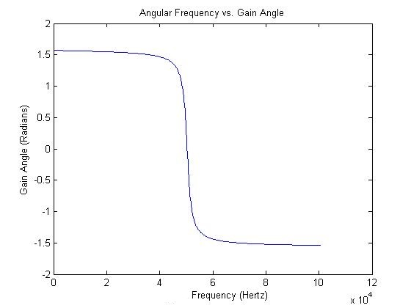

There is a very small difference that is unnoticeable in this domain and range on the graph.

QUESTION 1 PART d

Part a

R=33Ohms

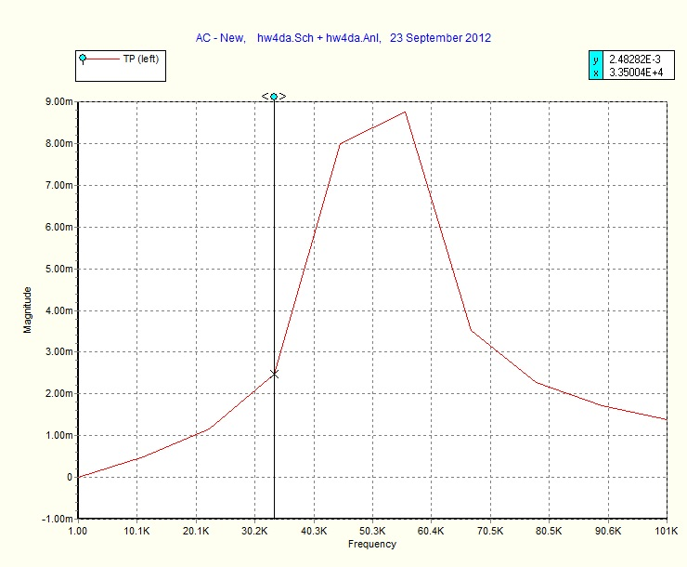

This graph has linear slopes that connect each other meaning the voltage changes in a linear equation that changes at each frequency spot.

Part b

R=100Ohms

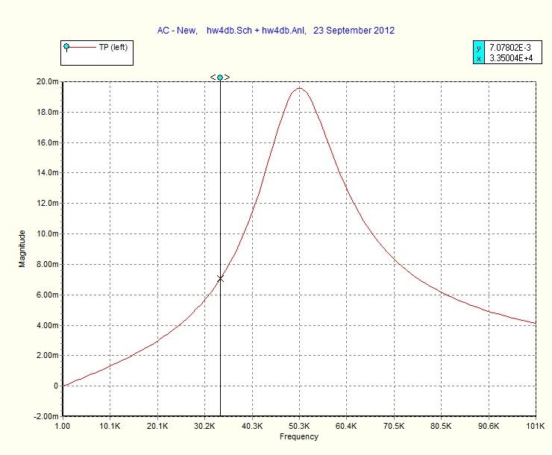

Part c

R=1000Ohms

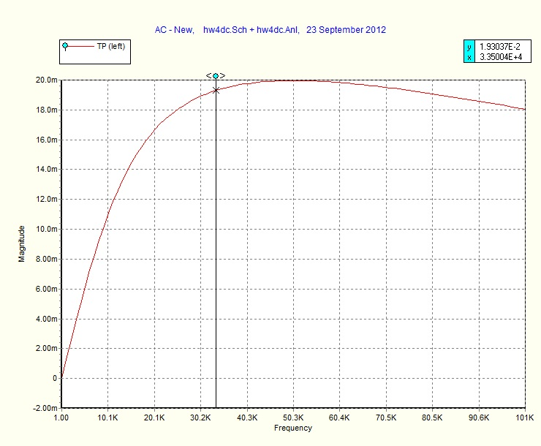

Part d

R=13Ohms

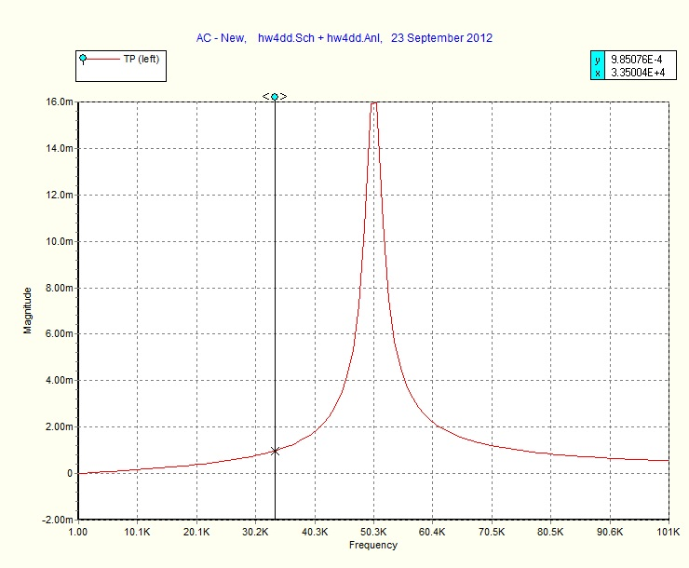

PROBLEM 2 – (chapter 22 problem 22)

R=4.7e3;%Ohms

C=500e-12;%Farads

%part a - determine fc

fc=1/(2\*pi\*R\*C)

%part b - find Av=Vo/Vi @ f=0.1fc

f=0.1\*fc;

XC=1/(2\*pi\*f\*C);

Av=XC/sqrt(R^2+XC^2)

%part c - find Av=Vo/Vi @ f=10fc

f=10\*fc;

XC=1/(2\*pi\*f\*C);

Av=XC/sqrt(R^2+XC^2)

%part d - find frequency with Vo=(1/100)Vi

Vo=(1/100)\*Vi;

gain=Vo/Vi;

XC=R\*((1-gain^2)/gain^2)^(-1/2);

f=1/(2\*pi\*C\*XC)

fc = 6.7726e+004 Hz

Av = 0.9950

Av = 0.0995

f = 6.7722e+006 Hz

PROBLEM 3 – (chapter 22 problem 25)

fc=2e3;%cut off frequency

C=0.1e-6;%Farads

R=1/(2\*pi\*fc\*C)

Rnew=800; %Ohms = nearest commercial resistor

fcnew=1/(2\*pi\*R\*C)

f=[0.01\*fc:10:10\*fc];

XC=1./(1i\*2\*pi\*f\*C);

Av=1./sqrt((R./XC).^2+1);

plot(f,abs(Av));

R = 795.7747 Ohms

fc(new) = 2.0000e+003 Hz

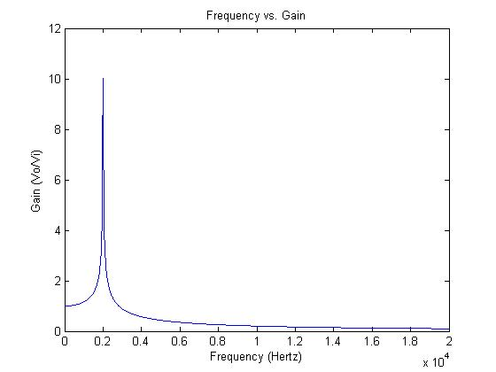

PROBLEM 4 – (chapter 22 problem 29)

Vi=1;

Rl=12;

L=4.7e-3;

C=560e-12;

R=0.16e3;

%part a - determine fs

fs=1/(2\*pi\*sqrt(L\*C))

%part b - calc Qs and BW for Vo

XL=2\*pi\*fs\*L;

Qs=XL/(Rl+R)

BW=fs/Qs

%part c -sketch Av with f=1e3-1e6

f=[1e3:100:1e6];

ZC=1./(1i\*2\*pi\*f\*C);

ZL=1i\*2\*pi\*f\*L;

ZR=R+Rl;

ZT=ZC+ZL+R;

Av=R./ZT;

plot(f,Av);

fs = 9.8102e+004 Hz

Qs = 16.8433

BW = 5.8244e+003 Hz

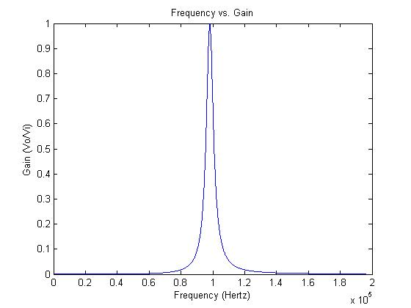

PROBLEM 5 – (chapter 22 problem 30)

R=3.3e3;

Rl=16;

L=1e-3;

C=0.001e-6;

%part a - determine Av for frequency range of 100Hz-1MHz

f=[100:10:1e6];

ZC=1./(1i\*2\*pi\*f\*C);

ZL=1i\*2\*pi\*f\*C;

ZR=R+Rl;

ZT=ZC+ZL+ZR;

Av=R./ZT;

plot(f, abs(Av));

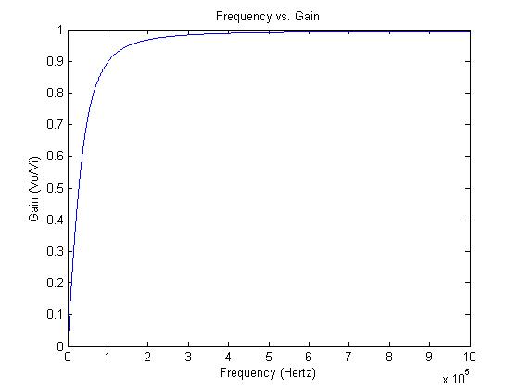

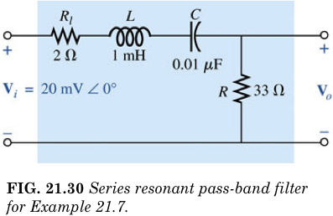

In the series resonant pass-band filter above, the voltage and current go through Rl in a linear fashion. When it hits the inductor, L, the current slows down and lags the voltage by 90 degrees. With the reactance equation being XL=1i\*w\*L, the voltage goes up as the frequency goes up until it hits maximum voltage. As the current and voltage hit the capacitor, the current leads the voltage by 90 degrees and they are back in phase. The reactance equation for a capacitor is XC=1/(1i\*w\*C), and this causes the voltage to drop at higher frequencies. The combination of only letting higher frequencies through first, then cutting off the allowed highest frequency second, causes only a certain frequency to carry voltage to the R resistor and this is pass-band filter.